TOTAL ( 104,873)

Origen : GUATEMALA

No # STYLE

DESCRIPTION

PRICE

QT'Y

COLOR

SIZES

PHOTO OF STYLE

PHOTO OF LABEL

COLOR COLOR
GREY STR

S
107

M
156

L
256

XL
204

XXL
109

LT XLT

XXLT 3XLT

TOTAL TOTAL
832

1 JTK-1201

URBAN
MENS SHORT SLEEVE CREW NECK SOLID EE
0% POLYESTER
50% COTTON

( 8,121)

20+

- XXL,
LT - 3XLT
BLACK CHARCOAL NAVY
WINE RED WHITE
L-GREEN HEATHER GREY ORANGE
AQUA OLIVE BLUE
D-TURQUOISE HEATHER OLIVE MINT TURQUOISE KAKI
D-NAVY LILAC
D-BEIGE PURPLE PINK
L-WINE L-KAKI
HEATHER CHARCOAL D-WINE
L-TURQUOISE L-RED
D-MINT L-GREY MELON
207
157
155
100
103
30
32
39
25
17
13
21
20
16
32
17
11
9

12
4
3
11
2
5
6
7
6
2
2
401
403
302
107
50
67
34
36
37
29
21
24
22
31
12
11
1
9
5
9
7
11
10
7
6
4
3
7
5
4
8
407
402
303
201
108
30
42
67
36
57
45
29
27
62
53
17
48
21
6
24
9
11
19
1
12
4
14
13
15
15
5
350
307
200
53
37
36
38
34
23
14
10
23
23
14
6
24
18
21
18
14
8
4
9
9
21
5
6
5
5
7
8
158
100
104
31
17
13
13
15
10
13
13
10
10
5
10
32
10
14
16
10
13
10
11
9
7
32
6
5
6
4
5
9 9
9 3
1 2
5 10
3 5

15 9

5 10
3 11
14 6
2 1
2 1

4

1 1
5 12

3 12
3 12

4 12
4 9
5 7
8 10
6 6
4 6

3 5

5 6
6 6
8 4
7 6
3

7 5

5 6
7 5

8 6
1,554
1,393
1,085
519
333
176
191
191
157
156
134
123
108
128
117
101
88
76
74
69
67
66
60
58
51
51
36
36
33
32
26

1,171 1,839 2,359 1,554 821 0

88 116 83 90

8,121

2 JTK-1202

URBAN
MENS SHORT SLEEVE W NECK
% POLYESTER 50% COTTON

( 6,103) ( 6) S - XXL

COLOR
NAVY/D-NAVY BEIGE/CHARCOAL GREY/CHARCOAL OLIVE/CHARCOAL CORAL/CHARCOAL SKY BLUE/CHARCOAL

S
207
209
158
159
100
51

M
308
305
209
206
159
107

L
500
505
403
309
208
101

XL
251
252
252
203
101
52

XXL
209
209
157
103
57
53

TOTAL
1,475
1,480
1,179
980
625
364

884 1,294 2,026 1,111 788 6,103

3 JTK-1203

URBAN
MENS SHORT SLEEVE "V" NECK
0% COTTON
50% POLYESTER

( 7,069) ( 15) S - XXL

COLOR BLACK NAVY
WHITE RED BLUE
L-GREEN OLIVE WINE ORANGE PURPLE CHARCOAL GREY MELON GREEN
D-BLUE

S
208
205
52
107
101
158
101
33
21
15
18
17
7
24
13

M
306
201
208
104
103
201
103
46
47
42
18
30
34
30
23

L
400
284
355
209
206
209
157
60
61
60
70
39
47
30
24

XL
256
159
109
156
109
103
51
66
65
54
32
39
15
32
23

XXL
194
102
134
108
100
105
54
26
18
39
38
29
26
24
16

TOTAL
1,364
951
858
684
619
776
466
231
212
210
176
154
129
140
99

1,080 1,496 2,211 1,269 1,013 7,069

URBAN MENS S/S V-NECK W/STRIPE
JTK-1204
4
% POLYESTER
14% COTTON

( 4,585) ( 3)S - XXL

COLOR
GREY STR CHARCOAL STR SKY BLUE STR

S
304
235
97

M
369
635
130

L
741
479
228

XL
444
198
108

XXL
304
212
101

TOTAL
2,162
1,759
664

636 1,134 1,448 750

617

4,585

COLOR

S M L

XL XXL

LT XLT

XXLT 3XLT

TOTAL

5 JEK-1205

URBAN
MENS SHORT SLEEVE CREW NECK RAGLAN TEE (BODY 90%
POLY, 10% CTTN)
E 50% COTTON
50% POLYESTER)

( 2,560) ( 9) S - XXL LT-3XLT
CHARCOAL/BLACK RED/BLACK BLUE/BLACK
D-YELLOW/CHARCOAL GREY/WINE GREY/GREEN GREEN/NAVY BEIGE/YELLOW
MIX
149
60
61
9
8
6
6
7
3
354
105
107
6
9
15

1
1
386
176
147
20
9
15
4
16
2
208
61
68
15
12
10
7
7
160
76
60
17
8
5
15
16
1
12 8 12 4
9 9 8 6
2 1 4 3
2 3 3 6
6 8 4 5

4 4 5 4
1,293
510
453
81
69
51
49
47
7

309

598

775

388

358 0

35 33

36 28

2,560

URBAN
6 JEK-1206 S MUSCLE TANK
% COTTON
50% POLYESTER

( 204) ( 7) S - XXL

COLOR WHITE/CHARCOAL GREY/BLACK
CHARCOAL/BLACK BLACK/CHARCOAL RED/CHARCOAL AQUA/SKY BLUE BLUE/BLACK
MIX

S M
7 8
4 9
1 2
3

1 1

8 11

L XL
8 6
10 11
4 10
8 7
5 4
5
1 1
11 5

XXL
11
5
17
9
2

2
7

TOTAL
40
39
34
27
11
7
4
42

21 34

52 44 53

204

COLOR

S M L

XL (HUSKYL(HUSKY)

TOTAL

7 JTK-1207

URBAN
BOYS LONG SLEEVE CREW NECK RAGLAN

50% COTTON, 50% POLYESTER

S - XL,
( 11,808) ( 18) L(HUSKY)
XL
(HUSKY)
GREY/BLACK TURQUOISE/CHARCOAL BLUE/BLACK WINE/BLACK
SKY BLUE/NAVY GREEN/BLACK WHITE/NAVY CORAL/GREY RED-CHARCOAL
L-GREY/CHARCOAL CHARCOAL/BLACK SKY BLUE/NAVY 2 YELLOW/NAVY CHARCOAL/GREEN WHITE/BLACK WHITE/WINE NAVY/RED GREY/OLIVE
321
348
409
307
259
258
170
156
107
69
80
65
31
41
40
21
16
7
495
486
452
458
356
318
361
202
125
98
119
94
40
46
43
28
10
10
358
404
446
406
240
258
190
151
99
92
85
73
52
22
16
14
6
12
323 29 34
255 27 34
202 18 25
204 42 26
196 27 23
204 11 15
122 16 27
104 16 19
82
75
71
79
37
21
21
19
28
6
1,560
1,554
1,552
1,443
1,101
1,064
886
648
413
334
355
311
160
130
120
82
60
35

2,705 3,741 2,924 2,049 186

203

11,808

COLOR

S M L

XL XXL LT

XLT

XXLT 3XLT

2XB

3XB

4XB

TOTAL

8 JYK-1101

ONOMA
MENS SHORT SLEEVE CREW NECK RAGLAN TEE
50% POLYESTER 38%
COTTON 12% RAYON

S-XXL,
( 1,052) ( 4) LT-3XLT, 2XB-4XB
GREEN/BLUE GREY/CORAL BLUE/NAVY WHITE/GREY
2 5 6
2 1 1
4 6 9 12
1 1 2
36
1 24
3 10
1
47 121
26 56
13 7
106
46
7
38
101
10
69 70
104 95
9
500
457
90
5

7 8 16 21

5 70

86 184

159

149

173

174

1,052

9 JYP-1102

RT & COMPANY MENS LONG SLEEVE CREW NECK SOLID EE
100% COTTON

( 3,017) ( 10) S - XL 2XL-4XL

COLOR CHARCOAL LILAC
SKY BLUE BLUE
D-WINE WHITE BLACK YELLOW OLIVE MINT AQUA CORAL ORANGE GREEN WINE LIME NAVY
D-CORAL FUCSHIA TURQUOISE MIX

S M
46 66
46 9
48 48
25 82
25 14
40 53
9 46
27 40
70 15
31 18
4 30
17 36
40
3 14
34

30
13 24
1 3
1 10
5 2

L XL
196 91
100 44
64 2
48 25
51 21
45 18
40 2
47 24
18 19
8 31
17 14
30 17
34 9
13 19
30
39 15
30
22
14 19
6 14
2 3

2XL
54
76
26
23
65
26
57
33
12
4
26

13
14
19
23
27

17
4
2

3XL

10
29

5
14
22

35
12

32

11

4XL

5
14

20

10

11

TOTAL
453
290
231
203
201
196
186
171
134
127
103
100
96
95
94
88
87
59
54
35
14

411

614

854

387

521

170 60

3,017

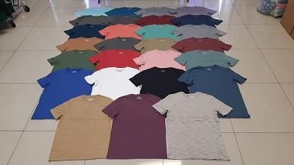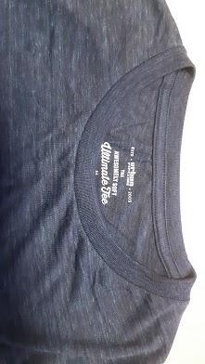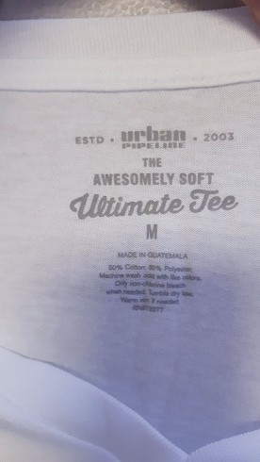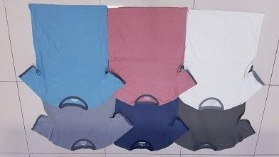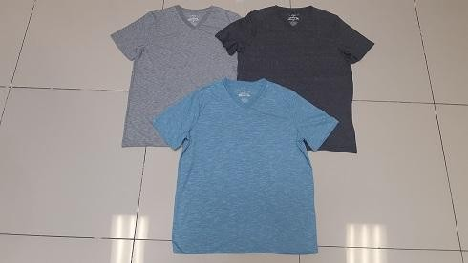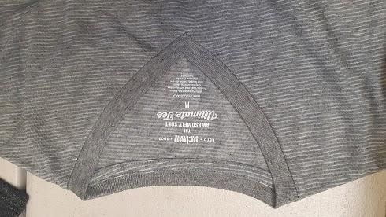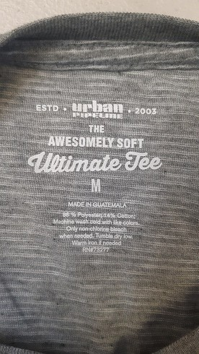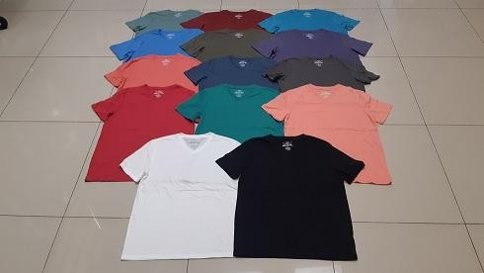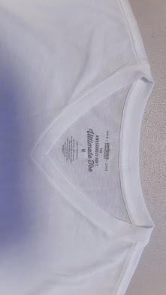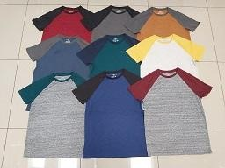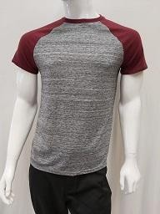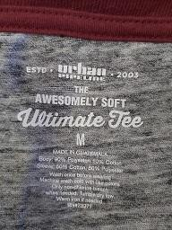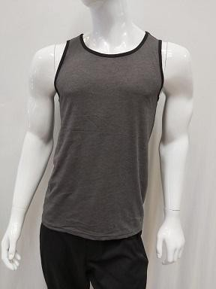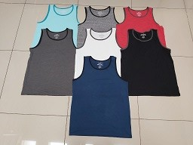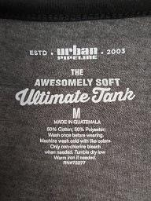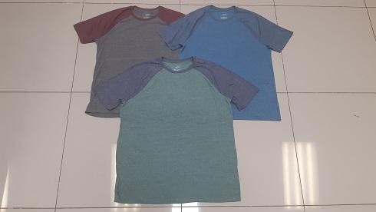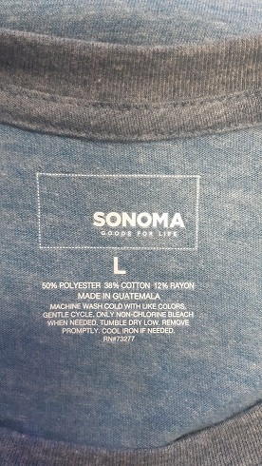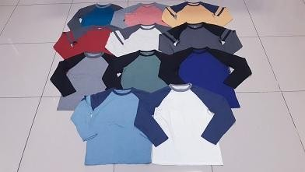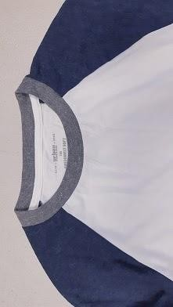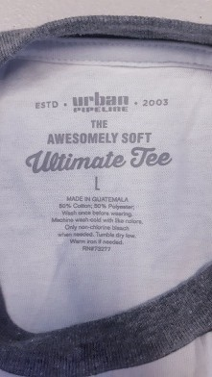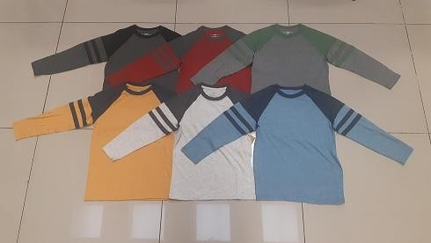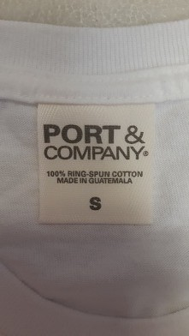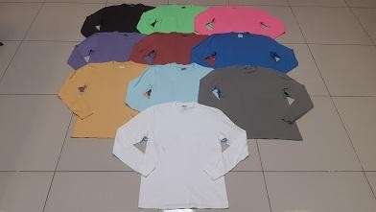
COLOR SKY BLUE OLIVE

S M L

1 1

XL
261
41

2XL

133

TOTAL
261
176

 |  |  | TOTAL ( 104,873) |  |  |  | Origen : GUATEMALA
No | # STYLE | DESCRIPTION | PRICE | QT'Y | COLOR | SIZES | PHOTO OF STYLE |  | PHOTO OF LABEL | COLOR |  |  |  |  |  |  |  |  |  |  |  |  | TOTAL
 |  | RT & COMPANY |  |  |  |  | 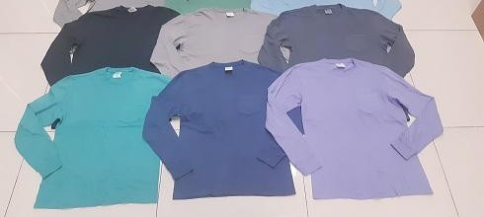 | 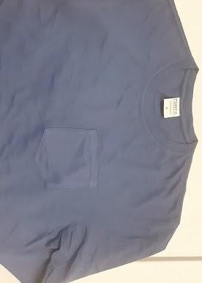 | 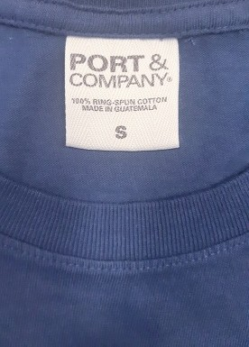 | MINT | 20 | 46 | 7 | 38 |  |  |  |  |  |  |  |  | 111
 |  |  |  |  |  |  |  |  |  | NAVY | 31 | 33 | 2 |  | 16 |  |  |  |  |  |  |  | 82
 |  |  |  |  |  |  |  |  |  | CHARCOAL | 8 | 20 | 14 | 15 | 23 |  |  |  |  |  |  |  | 80
10 | JYP-1103 | ENS S/S  CREW NECK  D TEE W/POCKET |  | ( 828) | ( 10) | S - 2XL
 |  |  |  |  |  |  |  |  |  | BLACK | 2 |  | 49 | 11 |  |  |  |  |  |  |  |  | 62
 |  |  |  |  |  |  |  |  |  | LILAC | 23 |  |  |  |  |  |  |  |  |  |  |  | 23
 |  |  |  |  |  |  |  |  |  | GREEN |  | 6 | 10 |  |  |  |  |  |  |  |  |  | 16
 |  | 100% COTTON
 |  |  |  |  |  |  |  |  |  | D-CORAL |  |  |  | 14 |  |  |  |  |  |  |  |  | 14
 |  |  |  |  |  |  |  |  |  | WHITE | 3 |  |  |  |  |  |  |  |  |  |  |  | 3
 |  |  |  |  |  |  |  |  |  |  | 88 | 105 | 83 | 380 | 172 |  |  |  |  |  |  |  | 828
 |  |  |  |  |  | S - XXL , L PLUS - XL PLUS | 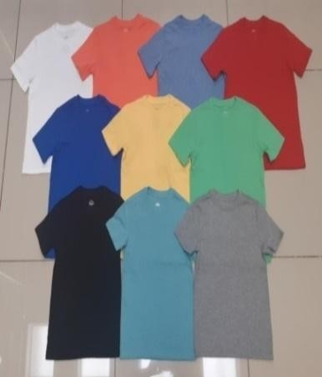 | 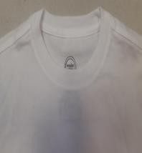 | 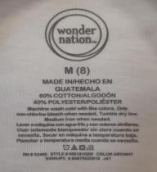 | COLOR | XS | S | M | L | XL | 2XL |  | L-H | XL-H |  |  |  | TOTAL
 |  |  |  |  |  |  |  |  |  | BLACK | 1,298 | 2,541 | 3,069 | 2,084 | 1,101 | 705 |  | 407 | 400 |  |  |  | 11,605
 |  |  |  |  |  |  |  |  |  | WHITE | 1,000 | 1,502 | 2,046 | 1,500 | 1,058 | 704 |  | 304 | 300 |  |  |  | 8,414
 |  | WONDER NATION |  |  |  |  |  |  |  | RED | 809 | 1,211 | 1,440 | 1,445 | 809 | 607 |  | 301 | 301 |  |  |  | 6,923  6,587  5,677
 |  |  |  |  |  |  |  |  |  | BLUE | 801 | 1,223 | 1,414 | 1,234 | 805 | 505 |  | 301 | 304
 |  |  |  |  |  |  |  |  |  | WINE | 817 | 1,212 | 1,435 | 1,203 | 601 | 409 |  | 0 | 0
11 | JAWN-1201 | OYS S/S  REW NECK |  | ( 59,526) | ( 10) |  |  |  |  | GREEN | 823 | 1,118 | 1,128 | 1,106 | 605 | 409 |  | 0 | 0 |  |  |  | 5,189  5,305
 |  |  |  |  |  |  |  |  |  | NAVY | 822 | 1,147 | 1,107 | 1,014 | 609 | 401 |  | 104 | 101
 |  |  |  |  |  |  |  |  |  | ORANGE | 572 | 1,040 | 1,002 | 1,013 | 405 | 202 |  | 0 | 0
 |  | 0% COTTON  40% POLYESTER |  |  |  |  |  |  |  |  |  |  |  |  |  |  |  |  |  |  |  |  | 4,234  3,533  2,059
 |  |  |  |  |  |  |  |  |  | GREY | 488 | 375 | 1,016 | 1,043 | 304 | 104 |  | 101 | 102
 |  |  |  |  |  |  |  |  |  | YELLOW | 302 | 324 | 621 | 609 | 100 | 103 |  | 0 | 0
 |  |  |  |  |  |  |  |  |  |  | 7,732 | 11,693 | 14,278 | 12,251 | 6,397 | 4,149 | 0 | 1,518 | 1,508 |  |  |  | 59,526

